Adverbs/Prepostions of Location Nombre _____________________
introducción Clase _______ Fecha __________
Goal: Use estar to talk about location and condition
- cerca (de) = near/close - enfrente (de) = facing/across from/(in front of)
- lejos (de) = far - detrás (de) = behind
- a la izquierda (de) = to the left - encima (de) = above/on top of
Estar
estoy estamos
estás estáis
está están
- a la derecha (de) = to the right - sobre = above/on top of
- en = in/on - debajo (de) = below/underneath
- al lado (de) = beside/aside/next to - dentro (de) = inside
- entre = in between - contra – against(i.e.contra la pared)
- en la esquina – in the corner - delante (de) = in front (of)
.

- ** The preceding vocab list is ADVERBS of locations. (WITHOUT “de”)

- *** When they are followed by a noun, they become PREPOSTIONS of location. (WITH “de”)

- Write the location phrases in Spanish.

  - on top of
  - in/on
  - under
  - behind

- Write the correct form of estar.

- Tú ____________________ cansado.
- Miguel ____________________ contento.
- Usted ____________________ nervioso.
- Mis hermanos y yo ___________________ tranquilos.
- Yo ____________________ triste.

- ¿ ____________________ ellas enojadas?
- Los chicos ____________________ contentos.
- Ana y yo ____________________ tristes.
- ¿ ____________________ tú nervioso?
- Ustedes ____________________ cansados.

- Where’s the cat? Use each word from the box only once. The first one is done for you.
Positions
encima de
delante de
detrás de
debajo de
al lado de
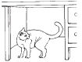
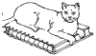
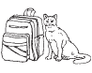
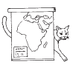
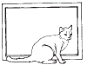
1. 2. 3. 4. 5.

- El gato está debajo del escritorio.________________________________.
- ___________________________________________________________.
- ___________________________________________________________.
- ___________________________________________________________.
- ___________________________________________________________.

F) Fill in the blanks with the correct location vocabulary.

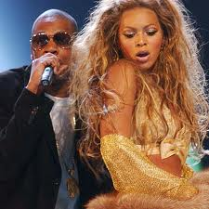
1. Beyoncé Y Lay Z están ___ concierto.
2. Beyoncé está _______ ____ Lay Z.
3. Lay Z está _______ ____ Beyoncé.
4. Paris France está ___la cárcel (jail).
5. Paris France está _______ ____ la cárcel (jail).
6. Paris France está _______ ___ las barras (bars).
7. Alicia KeyChain está __________ del piano.
8. Alicia KeyChain está __________ el piano.
9. ¿ Charlie Sheen está ____ ______ la influencia
del alcohol y otras drogas?
10. Charlie Sheen está _________ ___ su familia, no delante.

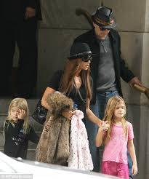

UNIT 2 LESSON 2

