España: Webquest Nombre: ________________________
A) Colorear las REGIONES de España en el mapa.
Usa el enlance (link) más abajo: http://www.red2000.com/spain/region/
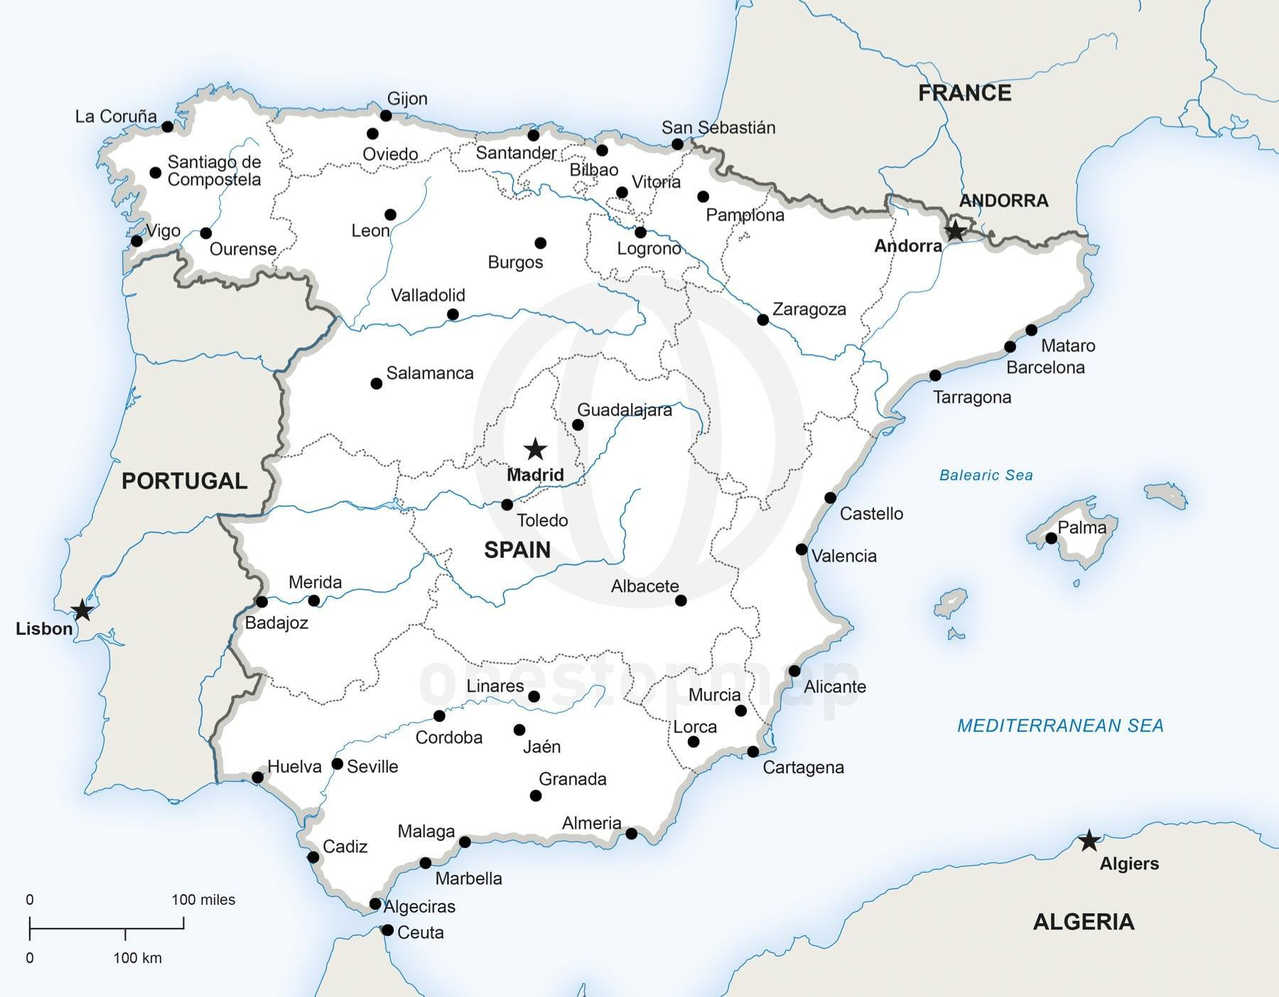https://www.onestopmap.com/product/printable-vector-map-spain-political-17/

B) la plaza Mayor
http://www.lonelyplanet.com/spain/madrid/sights/squares-plazas/plaza-mayor
- When was “la plaza Mayor” designed?
- What activities took place in “la plaza Mayor” during the inquisition?
- Describe the obscure color of the apartments?
- How many balconies open up to “la plaza Mayor”?

C) la plaza Mayor- video
https://www.youtube.com/watch?v=SkeOIuhFT5A
- What do you see in the middle of “la plaza Mayor” at (0:13) ?
- What type of professional do you see at (0:20) ?
- Would you like to take part in the activity at (0:35) ?
- What is being celebrated at “la plaza Mayor” as seen at (1:00) and (1:20) and (1:30) ?
- What type of street performer do you see at (1:13) ?
- What type of street performer do you see at (1:25) ?
- What type of professional do you see at (1:40) ?
- What shops do you see at (1:57) ?
- What shops do you see at (2:15) ?
- What shops do you see at (2:21) ?

D) parque del buen Retiro
http://www.madridtourist.info/buen_retiro_park.html
- What does “parque del buen Retiro” mean?
- When was the “parque del buen Retiro” started?
- What did King Philip have created in the 1600s-- and what does that word mean?
- Which building or attraction do you think is the most interesting, and WHY? (Do not say ‘none’).

E) parque del buen Retiro- video
https://www.youtube.com/watch?time_continue=10&v=rEaRw7KX5ZQ
- Tell me the time stamp in the video that shows your favorite part of the park.
- State why it is your favorite part.
- Tell me the time stamp of your least favorite, and why.

F) la sagrada Familia
https://en.wikipedia.org/wiki/Sagrada_Fam%C3%ADlia
- When did construction begin on the basilica?
- Why has it not been finished yet?
- What is the projected date.

G) el museo Guggenheim en Bilbao
https://www.youtube.com/watch?v=naWIQhV057Y
- Summarize and highlight the narration of the video.

- Which part of the video do you find most interesting, and WHY? ( Do not say ‘none’)

- Which part of the video do you find least interesting, and WHY? ( Do not say ‘none’)

