 These are a few of my favorite things...

Actividades favoritas de mi niñez

Nombre:________________________ Fecha: _________ Períod: _____

1. Personalize. Rate how your USED to like/love/hate the following childhood

ACTIVITIES in order of your USED to love most vs. least.

Write the activity that comes in 1st place for you, 2nd, 3rd, … 20th

1. Write in Spanish “I USED TO like/love/bothered…+ the sport”
2. Click and drag the **ClipArt** choices for each sport, and place them to the right of your

Spanish sentence.

1. **E-mail** it to me via my school website. Do **not** make a hard copy.

MCj02416070000[1]

Ex: example → ***Me encantaba jugar al tennis.*** →

========================================================================================

[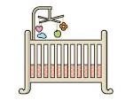](http://www.google.com/url?q=http://www.clipartlord.com/category/baby-clip-art/crib-clip-art/&sa=U&ei=fpdqU4fICcKtyATQlYHIDQ&ved=0CDoQ9QEwBQ&sig2=oLsEhUmACFUzyW0o3BU_3A&usg=AFQjCNGDBbaIusgbxNGcyjqZZIzANPmGLA)

[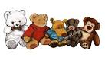](http://www.google.com/url?q=https://www.etsy.com/listing/126324475/freehand-clip-art-painting-of-five&sa=U&ei=25NqU6jAMMKfyASA8oLABw&ved=0CDAQ9QEwATgo&sig2=dqsmfQxp-6eTdxE5IPLInQ&usg=AFQjCNFOuieOcIdUEiEUWyc3OiQB4oSfEg)[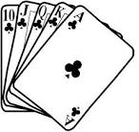](http://www.google.com/url?q=http://bestclipartblog.com/23-cards-clip-art.html/cards-clip-art-15&sa=U&ei=0plqU5OpI4OyyASUyoG4Bg&ved=0CEQQ9QEwCg&sig2=Z_scUDN49jr9lUOJRr9r-g&usg=AFQjCNHKIWgdh9mwu7YqCAbeEjYVxVAbfw)[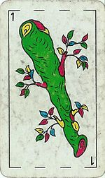](http://en.wikipedia.org/wiki/File:Bastos_Ace_spanishdeck.jpg)1er  lugar→

[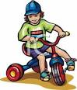](http://www.google.com/url?q=http://www.picturesof.net/pages/090615-172070-575042.html&sa=U&ei=9pNqU-vSGM6gyAS7y4KYCg&ved=0CFQQ9QEwEzgU&sig2=FmD96yqsi4kGJI4MWG1VWQ&usg=AFQjCNHRt_pB32rnnHerB-64F2L0C-JrMg)[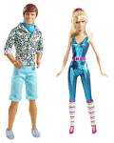](http://www.google.com/url?q=http://theredlist.com/wiki-2-24-224-267-view-fiction-profile-barbie-ken.html&sa=U&ei=E5BqU7rbLoqPyASswYDgCg&ved=0CDAQ9QEwAQ&sig2=tJW-DL9f9Z4He-WcVwpMYQ&usg=AFQjCNHWQG0BJQ2_lbn83qHRlIUQCNgErA)2o lugar→

[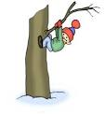](http://www.google.com/url?q=http://www.calvaryaustin.com/2013/01/&sa=U&ei=Q5RqU8-BMs60yAT8ooDgCw&ved=0CDAQ9QEwAQ&sig2=TzTbQjkdYsU2c3_caZhtkg&usg=AFQjCNH5bYqW6ndL2HTjQRaJGNsyUdlAEA)[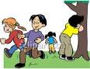](http://www.google.com/url?q=http://www.picturesof.net/pages/080711-299963-627043.html&sa=U&ei=6ZFqU5K2CMu2yATn0oH4Bw&ved=0CDoQ9QEwBg&sig2=KLvTWUg9XiWmNJH_m5rHpg&usg=AFQjCNEUDp4jK-o7UZtaiF4eEQGFI_kPcA)3er  lugar→

[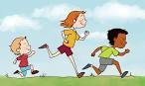](http://www.google.com/url?q=http://imgarcade.com/1/kids-running-race/&sa=U&ei=vZRqU5MoyYbIBO-ggKAK&ved=0CEAQ9QEwCTg8&sig2=e-NtIQPCbRihAu-69j2rdw&usg=AFQjCNE3DAYmGDHiWEuLt6XghMRtY11Iqg)[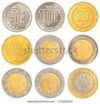](http://www.google.com/url?q=http://www.shutterstock.com/s/%22mexican%2Bcurrency%22/search.html&sa=U&ei=PJJqU5XpJpCkyAT7uIGQDQ&ved=0CFAQ9QEwEQ&sig2=kmNM7-ThwkUbjP56kQOpxQ&usg=AFQjCNEwV0962occTLE3YMBoMNdpW3tTtA)4o  lugar →

5o lugar→

[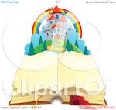](http://www.google.com/url?q=http://www.clipartof.com/portfolio/visekart/illustration/open-aged-book-with-blank-pages-and-a-fairy-tale-castle-1117144.html&sa=U&ei=TJVqU7rDHNioyATigYGoDQ&ved=0CDQQ9QEwAw&sig2=T_5hyE1z0zePrirT_eBZVA&usg=AFQjCNEYTgtNL0ETYjp8jNtSaURzVba5_g)[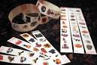](http://www.google.com/url?q=http://dabbletree.vrya.net/content.php?p%3D46&sa=U&ei=c5JqU-X6L8uPyASZ6oKgCQ&ved=0CDYQ9QEwBDgU&sig2=CC3ptLxPDmwg1ibqfZJi8Q&usg=AFQjCNFZMC1fdp059NumvtM-QYidFFXxvw)6o lugar→

[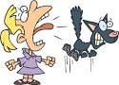](http://www.google.com/url?q=http://www.really-learn-english.com/hear-vs-listen.html&sa=U&ei=4pVqU-_rFcmjyATU74CYCg&ved=0CC4Q9QEwAA&sig2=ZQU4qYTdGOM4-WNUzxp3Rw&usg=AFQjCNF5iMRdFtFY0JHwi-07ycgetyYA7Q)[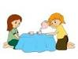](http://www.google.com/url?q=http://www.123rf.com/photo_1842429_illustration-of-kids-playing-house.html&sa=U&ei=jZJqU4T5FsyuyAT99IDYDQ&ved=0CDAQ9QEwAQ&sig2=jLUeHg850or-9JeLT6d1tA&usg=AFQjCNHx1ZYJaIoLsT9vCunFR9rD23R5Gw)7o lugar→

[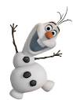](http://www.google.com/url?q=http://www.fanpop.com/clubs/olaf/images/36917838/title/olaf-frozen-fanart&sa=U&ei=_pVqU-SqDsayyATIjYGYAQ&ved=0CEgQ9QEwDQ&sig2=fTbz5hFLjkC7AwU1RuJ_eQ&usg=AFQjCNFF3AxZ99A3B5NDDsxqO_4-6g4NsA)[http://t1.gstatic.com/images?q=tbn:ANd9GcSg3k0wOX3ZqXoC1UrPGHVzQZzcsGrkdfHAwktV2J0ScRapLTW6VSD-Vw](http://www.google.com/url?q=http://www.clipartbest.com/children-clip-art-borders&sa=U&ei=s5JqU6PALoqryASqioCoAQ&ved=0CEwQ9QEwDw&sig2=ErlZYMxHY9NbjRUALlXXAg&usg=AFQjCNH6I6_Ma0Zri5dyUdDeE8xi9wHx9w)8o lugar→

9o lugar→

[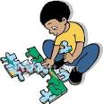](http://www.google.com/url?q=http://bestclipartblog.com/28-puzzle-clip-art.html&sa=U&ei=J5ZqU5zGEsGvyAS3yIKABQ&ved=0CDoQ9QEwBg&sig2=SbnEVty77zzM_gMN1Klt_A&usg=AFQjCNGDDCK0Lkz3ITqO2f8SNvgrpWITLA)[http://t2.gstatic.com/images?q=tbn:ANd9GcRUOGjjzWGt7EwkIAezelSKUXykifRnMcjX2BFQnjiIs0GSYZDyorTWcA](http://www.google.com/url?q=https://www.acclaimimages.com/photos-images/a_group_of_happy_little_children_playing_a_skipping_game.html&sa=U&ei=s5JqU6PALoqryASqioCoAQ&ved=0CEoQ9QEwDg&sig2=dNYLKyIfTzKKwYRZXPO6_w&usg=AFQjCNFjLpYqwnnMQ9w6hKa5jZJ6H8gIeA)10o lugar→

[](http://www.google.com/url?q=http://bestclipartblog.com/17-ghost-clipart.html/ghost-clipart-17&sa=U&ei=UJZqU--FO9a3yAT874DICQ&ved=0CC4Q9QEwAA&sig2=RgQCxqc9wF4SjZCFhmxajg&usg=AFQjCNFUVz483xJsC7r-WXbmVCN3icKWrg)[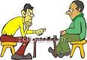](http://www.google.com/url?q=http://www.picturesof.net/pages/090116-182289-303042.html&sa=U&ei=-pJqU6m0BsGlyATkjILAAQ&ved=0CDQQ9QEwAw&sig2=n25vFkqEZEdpRxF2f9aaNg&usg=AFQjCNFFTX__pR4jM2fkCdq0FBPQyj8XrA)11o lugar→

[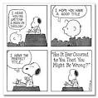](http://www.google.com/url?q=http://arncyn.squidoo.com/life-lessons-from-snoopy&sa=U&ei=FpdqU--QB86oyATX-oCYCg&ved=0CDIQ9QEwAjgU&sig2=XvyqYIxtYMdfLN3383qTjg&usg=AFQjCNHR6iCDh--bpbppfy82fo_sY1pkBA)[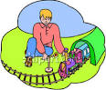](http://www.google.com/url?q=http://www.picturesof.net/pages/090417-016172-903042.html&sa=U&ei=j5NqU4ysLceSyATKkIDABg&ved=0CEAQ9QEwCThQ&sig2=b-XIWDkohp2oejoaojtsCg&usg=AFQjCNEcTuMK47raF6Y-AdGvSaE4npOoBw)[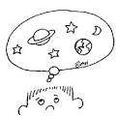](http://www.google.com/url?q=http://school.discoveryeducation.com/clipart/clip/daydream.html&sa=U&ei=F5NqU4-JNJSyyATZ6IGgDQ&ved=0CC4Q9QEwAA&sig2=yrPPg64kuaTqH7Po80vdgQ&usg=AFQjCNExbzuRDuffJ0szEHWVQ-5eHP8Uww)12o lugar→

[](http://www.google.com/url?q=http://www.picturesof.net/pages/090814-005223-850053.html&sa=U&ei=apdqU5vXMcKvyASD5oLYDg&ved=0CDAQ9QEwAA&sig2=SQ7jq6F7dL5OxYkoLw-LQA&usg=AFQjCNF2uBV1XdGJBcd1-JqShXdSvLX8Mg)13o lugar→MCj02154270000[1]MCj04324530000[1]MCj02129470000[1]MCj03187240000[1]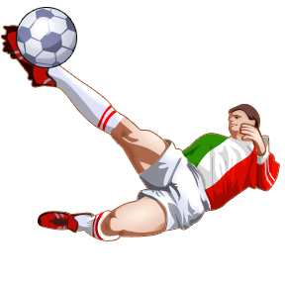MCj02154290000[1]

14o lugar→

15o lugar→

16o lugar→

17o lugar→

18o lugar→

19o lugar→

20o (ultimo) lugar→