 These are a few of my favorite sports...

Place your favorite sports

Nombre:________________________ Fecha: _________ Período: _____

1. Personalize. Rate the following sports in order of your most favorite to least favorite.

Write the sport that comes in 1st place (lugar) for you, 2nd, 3rd, … 13th

1. Write the Spanish sentence, “I like/love/care/irritated/bothered…+ the sport”
2. Then write Spanish sentence, :I (don’t) want to be a/an…(name of athelete)”
3. Click and drag the **ClipArt** choices for each sport, and place them to the right of your

Spanish sentence.

1. **E-mail** it to me via my school website. Do **not** make a hard copy.

MCj02416070000[1]

Ex: example lugar (place) → ***Me encanta jugar al tennis.***

***Quiero ser tenista.***

========================================================================================

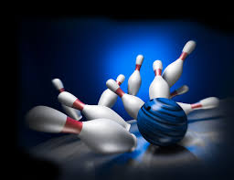MCj02153050000[1]1er  lugar→

MCj02986890000[1]2o lugar→

MCj04360170000[1]j01990363er  lugar→

4o  lugar →

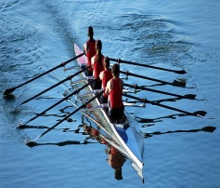5o lugar→

MCj02908610000[1]MCj02153060000[1]6o lugar→

MCj03187640000[1]MCj01209930000[1]7o lugar→

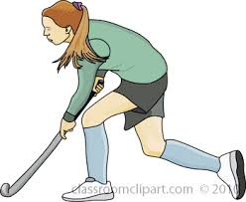8o lugar→

9o lugar→

10o lugar→

11o lugar→

12o lugar→

13o /ultimo lugar→MCj02154270000[1]MCj04324530000[1]MCj02129470000[1]MCj03187240000[1]MCj02154290000[1]