Citaciones: conjuntivos de condición
http://www.brainyquote.com/search_results.html?q=%22i+will%22&pg=6
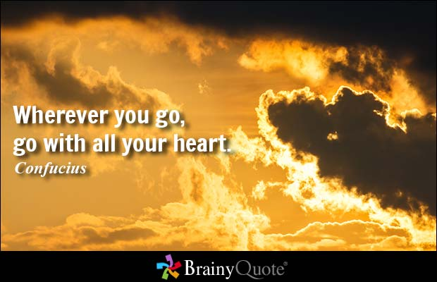
Fill in each space with the correct conjunction of condition, and with the correct verb and verb form. The verb can be - present indic, -pres subj, -past tense, -infinitive , or -command.
There are also some past participles.

- Wherever ______________you go______________, go with your heart.
Confucius

- Disciplining yourself to do what you know is right and important, although ______________difficult, is________ the highroad to pride, self-esteem, and personal satisfaction.
Margaret Thatcher

- Over every mountain there is a path, although ______________it may not be______________ seen from the valley.
Theodore Roethke

- Frustration, although ______________quite painful at times, is _______a very positive and essential part of success.
Bo Bennett

- And my mouth is not a sewer, although ______________some people may think ______________ that it is.
Laura Prepon

- Developing the muscles of the soul demands no competitive spirit, no killer instinct, although ______________it may construct ______________pain barriers that the spiritual athlete must crash through.
Germaine Greer

- I am always ready to learn although ______________I do not always like to be ______________taught.
Winston Churchill
- In the family, in interpersonal relationships, even in friendship, faith is tremendously important. If you have a partner who you believe is a good person, then it is your duty to have faith in them until the end, despite ______________the fact that they might have ______________done ______________some bad things. And you have to support and believe in your children.
Greg Graffin

- Despite ______________all I have ______________seen______________ and experienced, I still get the same simple thrill out of glimpsing a tiny patch of snow in a high mountain gully and feel the same urge to climb towards it.
Edmund Hillary

- We hold our heads high, despite t______________he price we have ______________paid______________, because freedom is priceless.
Lech Walesa

- Despite ______________our having ______________ever-connective technology, neither Skype nor Facebook - not even a telephone call - can come close to the joy of being with loved ones in person.
Marlo Thomas

- Let's remember the children who come from broken homes, surrounded by crime, drugs, temptation, their peers having babies out of wedlock, but who still manage to get a good education despite ______________the many obstacles they face ______________every day.
Armstrong Williams

- You win any which way______________ you can______________. You do what you have to do to get by. That's the way it works in any job.
Greg Rusedski

- I will continue to help the political causes I believe in, in any way ______________I can______________.
Alastair Campbell

- I've never covered the president in any way ______________other than that he is ______________ultimately responsible.
Helen Thomas

- I love TV in a way ______________that I don't love ______________any other medium.
Joss Whedon

- I just express myself in any way ______________I feel ______________is appropriate at the moment.
Herbie Hancock

- I think it would be a shame for any writer to let their publishers in any way ______________ lead ______________them into a single genre.
Emma Donoghue

- Increase of material comforts, in general, does not in any way ______________whatsoever lead ______________to moral growth.
Mahatma Gandhi

- And I can party with some of the heavyweights. There are some stories about me that, yeah, where ______________there's ______________smoke there's fire. But sometimes the smoke is just smoke.
Al Jourgensen

- Wherever ______________you go______________, no matter what the weather, always bring your own sunshine.
Anthony J. D'Angelo

- Let us dream of tomorrow where______________ we can ______________ truly love from the soul, and know love as the ultimate truth at the heart of all creation.
Michael Jackson

- Where ______________there is ______________no vision, there is no hope.
George Washington Carver

- You have brains in your head. You have feet in your shoes. You can steer yourself in any direction you choose. You're on your own, and you know what you know. And you are the guy who'll decide where______________ to go______________.
Dr. Seuss

- The only rule is don't be boring and dress cute wherever ______________you go______________. Life is too short to blend in.
Paris Hilton

- A birthday is just another day where ______________you go ______________to work and people give you love.
Abhishek Bachchan

- If art is to nourish the roots of our culture, society must set the artist free to follow his vision wherever______________ it takes ______________him.
John F. Kennedy

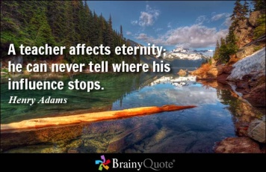
- All free men, wherever ______________they may live______________, are citizens of Berlin. And therefore, as a free man, I take pride in the words 'Ich bin ein Berliner!'
John F. Kennedy

- A teacher affects eternity; he can never tell
where ______________his influence stops______________.
Henry Adams

30. The ultimate measure of a man is not where ______________he stands ______________in moments of comfort and convenience, but where he stands at times of challenge and controversy.
Martin Luther King, Jr.

